Mathematics
The Vocabulary of Location Using Etoys:
Where Can I Go?
Second – Third Grade Levels

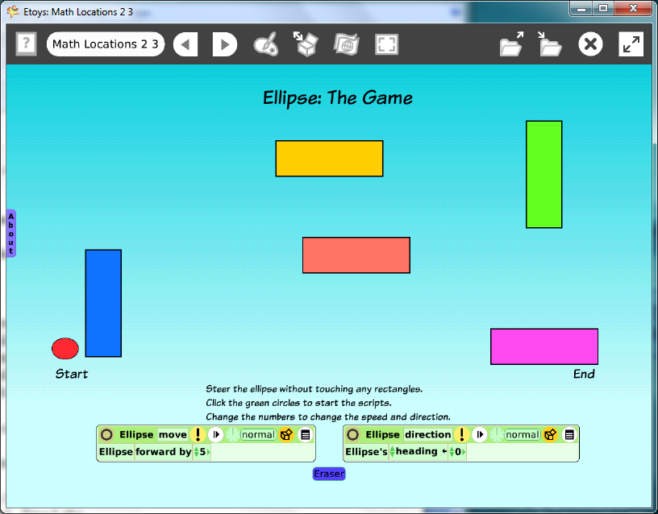

Introduction: | These two Etoys lessons give students a dynamic tool to explore a vocabulary of place and position that is useful both on and off of the computer. The geometric shapes are located using positions on the X-axis and Y-axis from information found in the Viewer of script tiles for each rectangle and the ellipse.
Topic: | Build a math vocabulary of position relationships on a grid.
Subject: | Mathematics
Time: | Lesson 1 Two Labs  Lesson 2 Two Labs
Description: | Students build a simple maze in Lesson 1. Lesson 2 uses the maze as a place for students to move an ellipse around on the computer screen to match the directions given by the teacher.
Vocabulary: | above, top, right, upper, center, on, up, beside, behind, below, bottom, left, lower, edge, near, down, before, between, X-axis, Y-axis, headings ( 0, 90, 180, -90), forward, turn
Evaluation Criteria: | Accurately positions shapes to match the requested location criteria.  Knows how to keep and find an Etoys project.  Creates two scripts that control the ellipses’ movement on the screen; a script that controls distance and another that controls heading.  Creates a script that clears pen trails.
Teacher Information:  Etoys Quick Guides: Click the question mark in  Etoys to open the set of tutorials about basic tools and techniques. | Etoys Quick Guides: Click the question mark in  Etoys to open the set of tutorials about basic tools and techniques.  Use Etoys Quick Guides if the lesson mentions unfamiliar tools or techniques. Give students time to read them too.
Goals: | Students build a working math vocabulary of position and place relationships useful on and off the computer screen by using x-axis and y-axis values to position geometric shapes in precise locations on the screen.  Students create scripts for motion and direction to steer their avatar through the maze.
Lesson 1:  Two labs  Halo: Color Property Sheet  Halo Handles: Viewer  Script Tiles: Forward by  Script Tiles: Heading  Halo Handles: Size, Color, Copy  Script Tiles: Exact Location  Navigator Bar: Keep Find Projects | Students create a maze and two scripts to move an ellipse on a path through the maze.  Drag an ellipse out of Supplies.  Use the Halo handles to change the color.  Open a Viewer for the ellipse and make a script using “ellipse forward by 5”.  Make another script with “ellipse’s heading 0”.  Change the heading to 90, 180 and -90 and ask students to experiment with steering their ellipse using the heading information.  Drag one rectangle from Supplies and make it about the size of a stick of gum.  Copy the rectangle four times and use the halo’s paint tool to make each copy a different color.  Open a Viewer for each rectangle and use its x and y information. Change their locations so that all x-axis and y-axis numbers end in a zero. Choose any number, the purpose is to give students practice seeing these numbers and using them.  Use the rectangles to create a maze.  Experiment and Discuss:  Give students time to move the ellipse with its scripts. They may need to adjust the locations of the rectangles and/or the size of the ellipse.  Ask students to describe they modified their project after trying to use the forward and heading scripts.  Give students time to experiment with their neighbor’s maze. How are the mazes similar and how are they different?  Give students time to modify their own project before publishing.  Publish the project with ‘namelocationdate’ E.G. ‘katelocationjan07’
Lesson 2:  Two Labs  Script Tiles:  Pen Use | Students use their maze project from Lesson 1 and add a pen trail to show the path the ellipse has traveled going through the maze.  Open the Viewer for the ellipse and click and hold down basic to open a menu. Choose Pen Use. Drop the tile “ellipse penDown false” into the forward by script and change false to true.  Create another script with the tile “Ellipse clear all pen trails”  Make the world background a beautiful color.  Open the Script Viewer for the world, choose fill and border.  Experiment with the effect of other tiles in this category.  Publish the project with the same name, a version number is added automatically.
Extend Lesson 2 | Discuss the idea of using the x and y co-ordinates to make their ellipse get as close to a rectangle without letting its pen trail touch the rectangle. Can they figure out that the pen trail is coming from the center of the ellipse?  Ask students to draw a path that shows the least amount of pen trail?  Ask students to draw a trail that goes around every rectangle.
Student Information: | Show students an example screen if an LCP projector is available or use a computer and show examples to small groups.
Standards: | Mathematics  Illinois Performance Standards  Second Grade: Measurement: Use appropriate units for measurement and recognize sensible measurements. 7A  Third Grade: Coordinate grids  Language Arts  Illinois State Goals K-3 Listening  4. A.1a Listen attentively by facing the speaker, making eye contact and paraphrasing what is said.  4. A.1b Ask questions and respond to questions from the teacher and from group members to improve comprehension.  4. A.1c Follow oral instructions accurately.  4. A.1d Use visually oriented and auditory based media  Language Arts  Illinois State Goals K-3 Speaking  4.B.1a Present brief oral reports, using language and vocabulary  appropriate to the message and audience (e.g. show and tell)  4.B.1b Participate in discussions around a common topic  National Educational Technology Standards (NETS)  1. Basic operations and concepts  Students demonstrate a sound understanding of the nature and operation of technology systems.  Students are proficient in the use of technology.  3. Technology productivity tools  Students use technology tools to enhance learning, increase productivity, and promote creativity.  Students use productivity tools to collaborate in constructing technology-enhanced models, prepare publications, and produce other creative works  4. Technology communications tools  Students use telecommunications to collaborate, publish, and interact with peers, experts, and other audiences.  Students use a variety of media and formats to communicate information and ideas effectively to multiple audiences.
Resources: | Etoys Help Quick Guides: Open Etoys and click the question mark in the Navigator Bar to open a set of interactive tutorials that introduce basic tools and techniques.  EtoysIllinois.org for projects, tutorials, and lesson plans  Squeakland.org to download Etoys software
kh
April 9, 2012

